**Final Year B. Tech., Sem VII 2022-23**

**Cryptography And Network Security**

**PRN: 2020BTECS00206**

**Full Name: SAYALI YOGESH DESAI**

**Batch: B4**

**Assignment No. 6**

1. **Aim:**

Given the plain text, encrypt it using Railfence Encryption Algorithm.

1. **Theory:**

Rail fence Cipher Encryption Algorithm:

* In the rail fence cipher, the plain-text is written downwards and diagonally on successive rails of an imaginary fence.
* When we reach the bottom rail, we traverse upwards moving diagonally, after reaching the top rail, the direction is changed again. Thus, the alphabets of the message are written in a zig-zag manner.
* After each alphabet has been written, the individual rows are combined to obtain the cipher-text.

1. **Code:**

#include<bits/stdc++.h>

using namespace std;

int main()

{

string s;

cout << "Enter plain text" << endl;

getline(cin, s);

string x;

for (int i = 0; i < s.length(); i++)

if (s[i] != ' ')

x += s[i];

s = x;

int k;

cout << "Enter key" << endl;

cin >> k;

cout << "\nPlain text is: " << s << endl;

cout << "Key is: " << k << endl;

int n = s.length();

vector<vector<char>> mat(k);

int row = 0;

int flg = 1;

for (int i = 0; i < s.length(); i++)

{

mat[row].push_back(s[i]);

row += flg;

if (row == (k - 1))

{

flg = -1;

}

if (row == 0)

flg = 1;

}

string cip = "";

for (int i = 0; i < k; i++)

{

for (int j = 0; j < mat[i].size(); j++)

cip += mat[i][j];

}

s = cip;

transform(cip.begin(), cip.end(), cip.begin(), ::toupper);

cout << "\nCipher text is: " << cip;

int tp = 1;

vector<vector<int>> matd(k);

row = 0;

flg = 1;

for (int i = 1; i <= n; i++)

{

matd[row].push_back(i);

row += flg;

if (row == (k - 1))

{

flg = -1;

}

if (row == 0)

flg = 1;

}

vector<int> dd;

for (int i = 0; i < k; i++)

{

for (int j = 0; j < mat[i].size(); j++)

dd.push_back(matd[i][j]);

}

cout << endl;

map<int, char> m;

for (int i = 0; i < n; i++)

m[dd[i]] = s[i];

string plain = "";

for (int i = 1; i <= n; i++)

plain += m[i];

cout << "\n\nPlain text after decription is: " << plain;

}

1. **Output:**

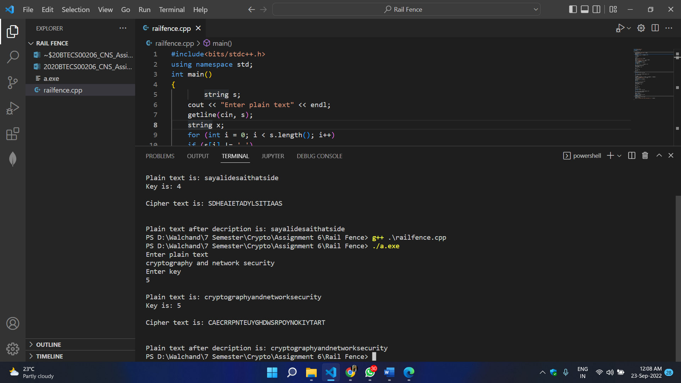

1. **Conclusion:**

Successfully encrypted plain text using rail fence cipher.